BACKGROUNDER
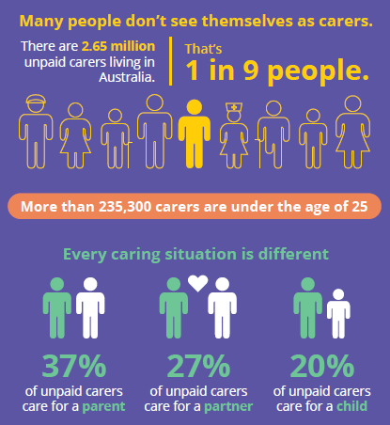
About this campaign

The Carer Gateway national advertising campaign aims to increase awareness of Carer Gateway services and supports, and encourage unpaid carers to use the phone line and website to access these supports.
Carer Gateway is a free support program for Australia’s 2.65 million unpaid carers, many of whom do not know that dedicated support is available to help them in their caring role.
Caring for others can be rewarding but tough, and it’s important that carers know that tailored support is available and can be easily accessed in-person, online or over the phone.
Informal carers provide a significant contribution to the health and wellbeing of Australians in need of support and assistance. While many carers report positive experiences, such as a sense of satisfaction and relief knowing that their loved ones are being cared for appropriately, many find that caregiving has its challenges.
Focusing on the true carer experience, the campaign showcases the struggle, sacrifice, effort, reward and joy that carers face day-in day-out.
The message
This powerful campaign prompts a very important question: If you’re looking after a loved one, who’s looking after you?

Source: Disability, Ageing and Carers, Australia: Summary of Findings, 2018 | Australian Bureau of Statistics (abs.gov.au)

With the tag line, ‘Help for those who might never ask’, the campaign acknowledges that many people don’t always identify as a carer, and for those who do, they may not always feel like they can reach out for the support they need.
Many people can become an unpaid carer at some time in their lives, even temporarily – it’s not something that is usually planned for, it can just happen. When and if that time comes, people need to know where to go for support.
Further information about services and supports available can be found on the Carer Gateway website.
How was the campaign developed?
The campaign’s approach and materials were informed throughout development by extensive market research across Australia. Research participants included a wide range of carers (including culturally and linguistically diverse (CALD) and First Nations), care recipients, disability and carer representative organisations and mainstream Australians.
What were the main research findings?
Key findings from market research included:
- Most people who care for family members and friends do not consider themselves as ‘carers’, they simply see themselves as a son, mother, friend or relative to the person they care for.
- People take on the caring role out of love, respect, and a sense of family duty or responsibility. Among First Nations and CALD audiences, ‘caring’ is very much considered a family and cultural responsibility.
- Sharing carer stories is an important.
- Carers don’t wish to acknowledge that they aren’t coping, so are reluctant to reach out for help and often don’t access support until they reach a crisis point.
- Carers are more motivated to seek support if they know there is a dedicated, free service that supports carers, rather than care recipients.

Where will I see advertising?
The Carer Gateway campaign will include national advertising from 16 October 2022 until October 2023 across television, digital, social media, radio, as well as in GP surgeries, targeting mainstream, First Nations and CALD carers.
What resources are available?
A range of resources and tools are available on CarerGateway.gov.au
What is the campaign call-to-action?
Call Carer Gateway on 1800 422 737 or visit CarerGateway.gov.au to register for support.

Media enquiries
Media enquiries can be emailed to media@dss.gov.au. Please include your name, media outlet, phone number and the deadline for your story.

