Case Study

Story of a First Nations carer looking after family members with mental illness

I live on Larrakia Country (Darwin) and I’ve been caring for two members of my family my entire life. They both live with mental illness, and go through periods of time when they are ok and others when they are very unwell. I see caring for them as a family obligation that is made easier when I reach out for the support and self-care I need.

When I was young, I helped around the home and looked after my sibling when my mum was unwell and went away for long periods of time. This was a really hard time because I didn’t understand what was wrong and there was little-to-no support for mental illnesses in my community. As I grew up, I realised I needed more support to care for my family.
As a young adult, it became clear I had forgotten to look after myself for a long time and I decided to move out of home for my own social and emotional wellbeing.
This helps keep me well and makes me a stronger carer for my family.

When I’m caring for them, my typical day involves helping to clean their house, driving them around town and to appointments, connecting them to services they might need, and being available in the case of
an emergency. I also often sit with them, which gives
them an opportunity to talk to someone because at times they can be very lonely and isolated.
There have been many challenging times in my life, but through focusing on caring for myself I’m now able to enjoy caring for my family members. They are quite vulnerable in the community, so I get a lot of good feelings helping them get around and do things.
When they’re getting help and are mentally well, it’s an amazing feeling for me because I’ve got my family back.

“This was a really hard time because
I didn’t understand what was wrong and there was little-to-no support for mental illnesses in my community. As I grew up, I realised I needed more support to care for my family.“

When I was younger, I didn’t know what support was available and I wasn’t confident to reach out for help because of feelings of shame and embarrassment. But I realised it was really important for me to get support for my own mental health. It’s easy for carers to feel isolated and become quite unwell without even realising it.

Your own wellbeing can easily spin out of control, so it’s very helpful to have a support network, friends and fun things to do. I still cry from time to time and feel anxious for my family, but I’m able to look after myself by being supported by services like Carer Gateway.
I really like using Carer Gateway. My favourite thing is that it’s a safe place to find information, which is easier than browsing the internet for the support I need.
There’s information on a whole range of topics and I’ve learnt about respite and guardianship. Through Carer Gateway, I was able to connect with a cleaning service in my local area that took the load off my shoulders.
As carers, we often don’t have a lot of time to look for support, but Carer Gateway has been designed with a carer in mind and is easy to use. Accessing face-to- face support has been harder than ever during the
COVID-19 pandemic, but Carer Gateway has been very helpful in providing me access to online and phone- based supports and services.
Carer Gateway delivers services in your local area and is there to support me and anyone caring for someone in their family or community.
If you need help you can call Carer Gateway or visit the website to get free and easily accessible support, find practical information, develop skills and improve your social and emotional wellbeing.

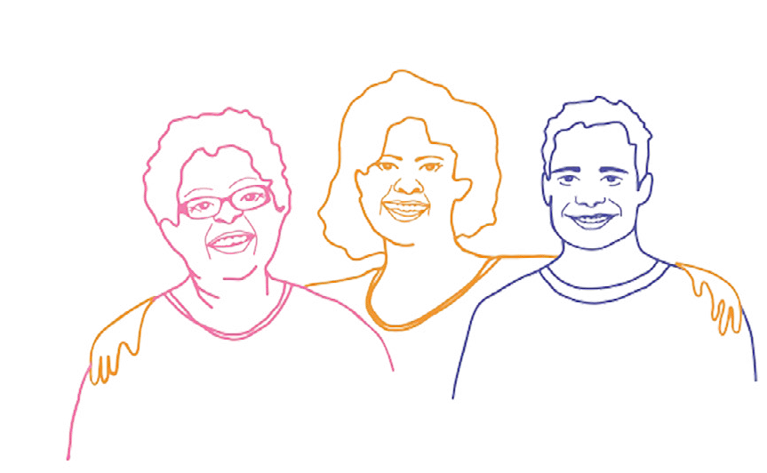

“I really like using Carer Gateway. My favourite thing is that it’s a safe place to find information, which is easier than browsing the internet for the support I need.“

Our communities are strongest when everyone is strong and it’s ok to reach out for support. Call 1800 422 737 or visit carergateway.gov.au/FirstNations

