Case Study

Sierra’s story – caring for her mum

I’m a proud Wiradjuri woman, living on Country (Bathurst) and I’m the sole carer for my mum. Her illness impacts her physically and mentally, and she often doesn’t feel comfortable or safe leaving the house. I’m a young woman and I’ve cared for my mum most of my life. Being a carer is part of who I am and caring for family is a big part of my culture.
My typical day changes depending on how mum is coping with her pain. Some days she needs me to do almost everything for her, but other days she is quite independent. I usually help her get ready for the day, drive her to any appointments, and do the cooking and chores around the house. Most days I don’t have lunch because there’s lots to do and not enough time. I always take an hour or so to sit with mum so that she has some social interaction. In the evening I try to take some time to relax and have some ‘me time’ where I
read, do homework or watch TV, but I’m always keeping an ear out if mum needs my help. During the night I’m often up with mum multiple times checking that she’s OK and helping her with anything she needs.
I don’t feel like a normal young person, I have a lot of challenges other people my age don’t have. I’ve had
to put off a lot of education, I don’t date and when I do go out with friends, it requires a lot of consideration and planning to make sure mum will be alright.

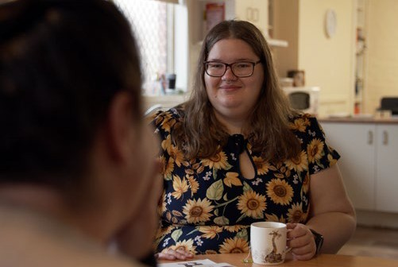

I also struggle with balancing caring for mum, studying and working. Most carers can understand that you don’t have time to wallow, you just keep going.
Despite the challenges, I enjoy having a closer relationship with mum. I’m great at teamwork and time management, and I’ve gained lots of helpful life skills like cooking, cleaning and paying bills, which I’m often teaching my friends how to do.

“I don’t feel like a normal young person, I have a lot of challenges other people my age don’t have. I’ve had to put off a lot of education,
I don’t date and when I do go out with friends, it requires a lot of consideration and planning to make sure mum will be alright.”

Growing up being a carer meant I withdrew a lot, which started taking a large toll on my mental and physical health. I was scared to ask for help and felt like it was hard to approach new services because I would have to tell my story over and over again. Thankfully, my sister reached out for help for me and there was more support available than I had ever realised. I now know that no one is going to judge me if I’m struggling and that everyone’s welcome and deserving of support,
no matter who they are or their level of caring.

Through Carer Gateway, I have connected with a case worker who I see as a great support and friend. She rings and checks in with me every couple of weeks, or more often if she knows I’m having a hard time. It was daunting to tell Carer Gateway my story, but I only had to say it once. My information is now kept on file and I don’t have to repeat it every time I need support. I often encourage my friends who are also carers to reach out to Carer Gateway because it’s helped me in many ways.
My connection to culture also supports me, and my community is like a big extended family around me. They’re always happy to help and show me I’m not alone, and that I’ve got this.
Carer Gateway delivers services in your local area and is there to support me and anyone caring for someone in their family or community.
If you need help you can call Carer Gateway or visit the website to get free and easily accessible support, find practical information, develop skills and improve your social and emotional wellbeing.

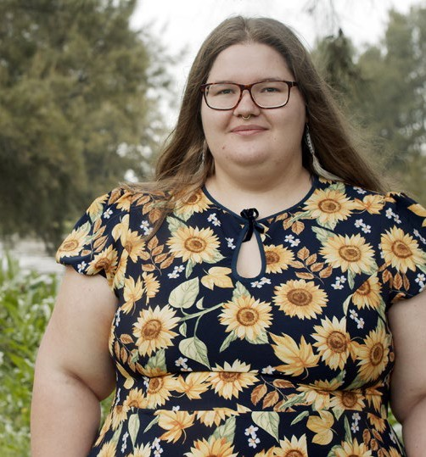

“Through Carer Gateway, I have connected with a case worker who I see as a great support and friend. She rings and checks in with me every couple of weeks, or more often if she knows I’m having a hard time. It was daunting to tell Carer Gateway my story, but I only had to say it once.”

Our communities are strongest when everyone is strong and it’s ok to reach out for support. Call 1800 422 737 or visit carergateway.gov.au/FirstNations

