Case Study

Story of a First Nations carer looking after her grandmother

I’m a proud Kabi Kabi woman living on Meanjin Country (Brisbane) and
I am a carer to my grandmother who lives with cancer. My two aunties are primary carers for my grandmother and for a few days a week, I provide respite care.

My grandmother is a very strong, proud woman and I know that it is difficult for her to welcome support. While this is her third time experiencing cancer, it is the first time she has accepted our help. I know it is challenging for her to accept that she can no longer do everything she once did, especially in her own home, but I am honoured to and enjoy the pride of caring for her.
One of the greatest challenges of being an unpaid carer to my grandmother is the lack of time we have to connect and bond. Instead of spending quality time with her, our days together are focused on providing care.
My caring responsibilities include giving medicine on time, helping with hygiene, cleaning, looking after the house, and running errands. For us, it is an important cultural and family obligation to help where we can.
As an Elder in our community, my grandmother has always been loving and welcoming to those around us, and her house is open to all. She has always cared for others and still offers her support to friends and family, so there are always visitors at her house. When I am providing respite care, I am also responsible for looking after the guests.

“One of the greatest challenges of being an unpaid carer to my grandmother is the lack of time we have to connect and bond. Instead of spending quality time with her, our days together are focused on providing care.”

I’m a working mum, and it can be challenging to be a carer as well. I can only provide respite care when my son is at school and when I can organise to be off work. Providing care can also be tiring and sometimes, I just need some extra support.
Finding resources and services can also be challenging and it can be especially hard when you don’t know where to look for support.
For me, having that extra support from Carer Gateway has been extremely helpful.
As a carer, it is important to look after yourself, otherwise you can be drained to the point of not being able to care for the one you love, or for yourself. Carer Gateway provides a place for unpaid carers to build connections and relationships with a community of people
with similar experiences. I’ve accessed Carer Gateway resources online and shared it with my aunties to get them the support they might need too. It’s good to know that Carer Gateway staff are trained in cultural awareness and if I ring Carer Gateway I can ask to speak to First Nations person.
Carer Gateway is there to support me and anyone caring for someone in their family or community. If you need help, you can call Carer Gateway or visit carergateway.gov.au to get free and easily accessible support, find practical information, develop skills, improve your social and emotional wellbeing and more. Carer Gateway delivers services in your local area.

“I’m a working mum, and it can be challenging to be a carer as well. I can only provide respite care when my son is at school and when I can organise to be off work. Providing care can also be tiring and sometimes, I just need some extra support.”

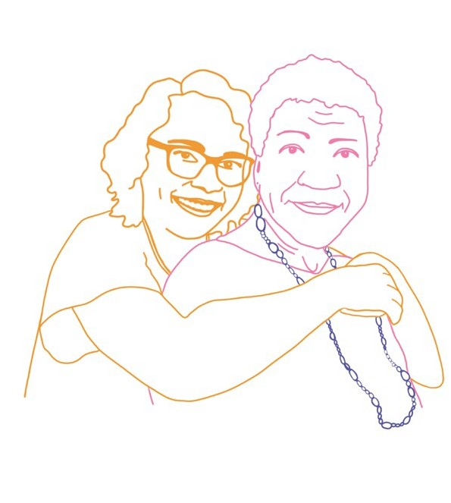

Our communities are strongest when everyone is strong and it’s ok to reach out for support. Call 1800 422 737 or visit carergateway.gov.au/FirstNations

